A NEW BLOCK-BASED REINFORCEMENT LEARNING APPROACH FOR DISTRIBUTED RESOURCE ALLOCATION IN CLUSTERED IOT NETWORKS
A PROJECT REPORT
Submitted by
SARANRAJ M
17ITR084
VAANMATHI S
17ITR105
YUVARANI D
16ITR116
in partial fulfilment of the requirements
for the award of the degree
of
BACHELOR OF TECHNOLOGY
IN
INFORMATION TECHNOLOGY
DEPARTMENT OF INFORMATION TECHNOLOGY

SCHOOL OF COMMUNICATION AND COMPUTER SCIENCES

KONGU ENGINEERING COLLEGE
(AUTONOMOUS) PERUNDURAI ERODE – 638 060

DEPARTMENT OF INFORMATION TECHNOLOGY
KONGU ENGINEERING COLLEGE
(Autonomous)
PERUNDURAI ERODE – 638 060
APRIL 2021
BONAFIDE CERTIFICATE

This is to certify that the Project Report entitled A NEW BLOCK-BASED REINFORCEMENT LEARNING APPROACH FOR DISTRIBUTED RESOURCE ALLOCATION IN CLUSTERED IOT NETWORKS is the bonafide record of project work done by SARANRAJ M (17ITR084) VAANMATHI S (17ITR105) and YUVARANI D (16ITR105) and in partial fulfilment of the requirements for the award of the Degree of Bachelor of Technology in INFORMATION TECHNOLOGY of Anna University Chennai during the year 2020-2021.

SUPERVISOR HEAD OF THE DEPARTMENT (Signature with seal)

Date:
Submitted for the end semester viva voice examination held on ___________

INTERNAL EXAMINER EXTERNAL EXAMINER
DEPARTMENT OF INFORMATION TECHNOLOGY
KONGU ENGINEERING COLLEGE
(Autonomous)
PERUNDURAI ERODE – 638 060
APRIL 2021
DECLARATION
We affirm that the Project Report titled A NEW BLOCK-BASED REINFORCEMENT LEARNING APPROACH FOR DISTRIBUTED RESOURCE ALLOCATION IN CLUSTERED IOT NETWORKS being submitted in partial fulfilment of the requirements for the award of Bachelor of Technology is the original work carried out by us. It has not formed the part of any other project report or dissertation on the basis of which a degree or award was conferred on an earlier occasion on this or any other candidate.

SARANRAJ M
(17ITR084)

VAANMATHI S
(17ITR105)

YUVARANI D
(16ITR116)
I certify that the declaration made by the above candidates is true to the best of my knowledge.

Date: Name and Signature of the Supervisor with seal

ABSTRACT

Resource allocation and spectrum management are two major challenges in the massive scale deployment of Internet of Things (IoT) and Machine-to-Machine (M2M) communication. Furthermore, the large number of devices per unit area in IoT networks also leads to congestion, network overload, and deterioration of the Signal to Noise Ratio (SNR). To address these problems, efficient resource allocation play a pivotal role in optimizing the throughput, delay, and power management of IoT networks. To this end, most of the existing resource allocation mechanisms are centralized and do not gracefully support the heterogeneous and dynamic IoT networks. Therefore, distributed and Machine Learning (ML)-based approaches are essential. However, distributed resource allocation techniques also have scalability problem with large number of devices whereas the ML-based approaches are currently scarce in the literature. In this paper, we propose a new distributed block-based Qlearning algorithm for slot scheduling in the smart devices and Machine Type Communication Devices (MTCDs) participating in clustered IoT networks. We furthermore, propose various reward schemes for the evolution of Q-values in the proposed scheme and, discuss and evaluate their effect on the distributed model. Our goal is to avoid inter- and intra-cluster interference, and to improve the Signal to Interference Ratio (SIR) by employing frequency diversity in a multi-channel system. Through extensive simulations, we analyze the effects of the distributed slotassignment (with respect to varying SIR) on the convergence rate and the convergence probability. Our theoretical analysis and simulations validate the effectiveness of our proposed method where, (i) a suitable slot with acceptable SIR levels is allocated to each MTCD, and (ii) IoT network can efficiently converge to a collision-free transmission causing minimum intra-cluster interference. The network convergence is achieved through each MTCD’s learning ability during the distributed slot allocation. All nodes are vitality obliged in mobile adhoc networks. It is essential to decrease vitality utilization furthermore increment the lifetime of the system in such circumstances. In this project, we have proposed Efficient Cluster Based Routing Protocol with Network Coding Technique. In MANET, Number of versatile nodes is gathered into a frame known as "clustering". In the cluster, based on the heaviness of the nodes the cluster head (CH) is chosen. In light of the dynamic cluster head choice approach the CH will choose the new CH as the vitality level of the cluster head lessens underneath the threshold vitality level. We have exhibited Particle Swarm Optimization (PSO) algorithm a to locate the ideal way in the system. By our proposed linear network coding procedure Number of transmissions in the ideal way can be lessened. From the simulation outcomes, we have demonstrated that our proposed approach diminishes the vitality utilization furthermore enhances the lifetime of the system.

TABLE OF CONTENTS
S. NO. |  | CONTENTS |  |  | PAGE NO.
 |  | ABSTRACT |  |  | iii
 |  | LIST OF FIGURES |  |  | vi
 |  | LIST ABBREVIATIONS |  |  | vii
1 |  | INTRODUCTION |  |  | 1
 |  | 1.1 |  | WIRELESS SENSOR NETWORK | 1
 |  | 1.2 |  | CLUSTER HEADACHE | 2
 |  | 1.3 |  | LEECHES | 2
 |  | 1.4 |  | LITERATURE REVIEW | 3
2 |  | SYSTEM ANALYSIS |  |  | 15
 |  | 2.1 | PROBLEM IDENTIFICATION |  | 15
 |  | 2.2 | FEASIBILITY STUDY |  | 16
 |  |  | 2.2.1 Economical Feasibility  2.2.2 Operational Feasibility  2.2.3 Technical Feasibility |  | 16  16  17
 |  | 2.3 | SYSTEM REQUIREMENTS  2.3.1 Software Requirements  2.3.2 Hardware Specification  2.3.3 Software Description |  | 18  18  18  19
 | 3 | SYSTEM DESIGN |  |  | 23
 |  | 3.1 | PROPOSED SYSTEM |  | 23
 |  | 3.2 | METHODOLOGY |  | 24
 |  | 3.3 | PROPOSED SYSYTEM FLOW DIAGRAM |  | 27
4 |  | SYSTEM IMPLEMENTATION |  |  | 28
 |  | 4.1 | EXPERIMENTAL RESULT |  | 28
5 |  | SYSTEM TESTING |  |  | 30
6 |  | CONCLUSION AND FUTURE ENHANCEMENT |  |  | 33
 |  | 6.1 | CONCLUSION |  | 33
 |  | 6.2 | FUTURE ENHANCEMENT |  | 33
 |  | APPENDIX 1 SAMPLE CODING |  |  | 34
 |  | APPENDIX 2 SCREENSHOTS |  |  | 42
 |  | REFERENCES |  |  | 46

LIST OF FIGURES

FIGURE NO. | TITLE | PAGE NO.
1 | System Flow Diagram | 27
2 | Distribution Of Cluster Heads Over The Network | 29

LIST OF ABBREVIATIONS

Abbreviation | Full Form
CH | Cluster Head
MANET | Mobile Ad Hoc Network
PSO | Particle Swarm Optimization
WSN | Wireless Sensor Network
FRA | Feasible Role Assignments
RFID | Radio-Frequency Identification
BS | Base Station
CHS | Cluster Head selection.
CMU | Cluster member user

CHAPTER 1
INTRODUCTION
1.1 WIRELESS SENSOR NETWORK
Wireless sensor network (WSN) refers to a group of spatially dispersed and dedicated sensors for monitoring and recording the physical conditions of the environment and organizing the collected data at a central location. WSNs measure environmental conditions like temperature, sound, pollution levels, humidity, wind, and so on.
These are similar to wireless ad hoc networks in the sense that they rely on wireless connectivity and spontaneous formation of networks so that sensor data can be transported wirelessly. WSNs are spatially distributed autonomous sensors to monitor physical or environmental conditions, such as temperature, sound, pressure, etc. and to cooperatively pass their data through the network to a main location. The more modern networks are bi-directional, both collecting data from distributed sensors and enabling control of sensor activity. The development of wireless sensor networks was motivated by military applications such as battlefield surveillance; today such networks are used in many industrial and consumer applications, such as industrial process monitoring and control, machine health monitoring, and so on.
The WSN is built of "nodes" – from a few to several hundreds or even thousands, where each node is connected to one (or sometimes several) sensors. Each such sensor network node has typically several parts: a radio transceiver with an internal antenna or connection to an external antenna, a microcontroller, an electronic circuit for interfacing with the sensors and an energy source, usually a battery or an embedded form of energy harvesting. A sensor node might vary in size from that of a shoebox down to the size of a grain of dust, although functioning "motes" of genuine microscopic dimensions have yet to be created. The cost of sensor nodes is similarly variable, ranging from a few to hundreds of dollars, depending on the complexity of the individual sensor nodes. Size and cost constraints on sensor nodes result in corresponding constraints on resources such as energy, memory, computational speed and communications bandwidth. The topology of the WSNs can vary from a simple star network to an advanced multi-hop wireless mesh network. The propagation technique between the hops of the network can be routing or flooding. In computer science and telecommunications, wireless sensor networks are an active research area with numerous workshops and conferences arranged each year, for example IPSN, SenSys, MobiCom and EWSN. As of 2010, wireless sensor networks have reached approximately 120 million remote units worldwide.
1.2 CLUSTER HEADACHE
Cluster headache (CH) is a neurological disorder characterized by recurrent severe headaches on one side of the head, typically around the eye.^{[1]} There is often accompanying eye watering, nasal congestion, or swelling around the eye on the affected side. These symptoms typically last 15 minutes to 3 hours. Attacks often occur in clusters which typically last for weeks or months and occasionally more than a year. The cause is unknown. Risk factors include a history of exposure to tobacco smoke and a family history of the condition. Exposures which may trigger attacks include alcohol, nitroglycerin, and histamine. They are a primary headache disorder of the trigeminal autonomic cephalalgias type. Diagnosis is based on symptoms.
Recommended management includes lifestyle changes such as avoiding potential triggers. Treatments for acute attacks include oxygen or a fast-acting triptan. Measures recommended to decrease the frequency of attacks include steroid injections, civamide, or verapamil.Nerve stimulation or surgery may occasionally be used if other measures are not effective. The condition affects about 0.1% of the general population at some point in their life and 0.05% in any given year. The condition usually first occurs between 20 and 40 years of age. Men are affected about four times more often than women. Cluster headaches are named for the occurrence of groups of headache attacks (clusters). They have also been referred to as "suicide headaches".
1.3 LEECHES
Leeches are segmented parasitic or predatory worms that belong to the phylum Annelida and comprise the subclass Hirudinea. They are closely related to the oligochaetes, which include the earthworm, and like them have soft, muscular, segmented bodies that can lengthen and contract. Both groups are hermaphrodites and have a clitellum, but leeches typically differ from the oligochaetes in having suckers at both ends and in having ring markings that do not correspond with their internal segmentation. The body is muscular and relatively solid, and the coelom, the spacious body cavity found in other annelids, is reduced to small channels.
The majority of leeches live in freshwater habitats, while some species can be found in terrestrial or marine environments. The best-known species, such as the medicinal leech, Hirudo medicinalis, are hematophagous, attaching themselves to a host with a sucker and feeding on blood, having first secreted the peptide hirudin to prevent the blood from clotting. The jaws used to pierce the skin are replaced in other species by a proboscis which is pushed into the skin. A minority of leech species are predatory, mostly preying on small invertebrates.
The eggs are enclosed in a cocoon, which in aquatic species is usually attached to an underwater surface; members of one family, Glossiphoniidae, exhibit parental care, the eggs being brooded by the parent. In terrestrial species, the cocoon is often concealed under a log, in a crevice or buried in damp soil. Almost seven hundred species of leech are currently recognised, of which some hundred are marine, ninety terrestrial and the remainder freshwater.Leeches have been used in medicine from ancient times until the 19th century to draw blood from patients. In modern times, leeches find medical use in treatment of joint diseases such as epicondylitis and osteoarthritis, extremity vein diseases, and in microsurgery, while hirudin is used as an anticoagulant drug to treat blood-clotting disorders.
1.4 LITERATURE REVIEW
ROUTING TECHNIQUES IN WIRELESS SENSOR NETWORKS: A SURVEY
Jamal N. Al-Karaki,et.al,has proposed Wireless sensor networks consist of small nodes with sensing, computation, and wireless communications capabilities. Many routing, power management, and data dissemination protocols have been specifically designed for WSNs where energy awareness is an essential design issue. Routing protocols in WSNs might differ depending on the application and network architecture. In this article we present a survey of state-of-the-art routing techniques in WSNs. We first outline the design challenges for routing protocols in WSNs followed by a comprehensive survey of routing techniques. Overall, the routing techniques are classified into three categories based on the underlying network structure: flit, hierarchical, and location-based routing. Furthermore, these protocols can be classified into multipath-based, query-based, negotiation-based, QoS-based, and coherentbased depending on the protocol operation. We study the design trade-offs between energy and communication overhead savings in every routing paradigm. We also highlight the advantages and performance issues of each routing technique. The article concludes with possible future research areas.
Routing in sensor networks is a new area of research, with a limited but rapidly growing set of research results. In this article we present a comprehensive survey of routing techniques in wireless sensor networks that have been presented in the literature. They have the common objective of trying to extend the lifetime of the sensor network while not compromising data delivery. Overall, the routing techniques are classified based on the network structure into three categories: flat, hierarchical, and location-based routing protocols. Furthermore, these protocols are classified into multipath-based, query-based, negotiation-based, and QoS-based routing techniques depending on protocol operation. We also highlight the design trade-offs between energy and communication overhead savings in some of the routing paradigm, as well as the advantages and disadvantages of each routing technique. Although many of these routing techniques look promising, there are still many challenges that need to be solved in sensor networks. We highlight those challenges and pinpoint future research directions in this regard.[1]

A SURVEY ON SENSOR NETWORKS
Ian F. Akyildiz, Weilian Su, Yogesh Sankarasubramaniam, et.al,has proposed Recent advancement in wireless communications and electronics has enabled the development of low-cost sensor networks. The sensor networks can be used for various application areas (e.g., health, military, home). For different application areas, there are different technical issues that researchers are currently resolving. The current state of the art of sensor networks is captured in this article, where solutions are discussed under their related protocol stack layer sections. This article also points out the open research issues and intends to spark new interests and developments in this field.The flexibility, fault tolerance, high sensing fidelity, low cost, and rapid deployment characteristics of sensor networks create many new and exciting application areas for remote sensing. In the future, this wide range of application areas will make sensor networks an integral part of our lives. However, realization of sensor networks needs to satisfy the constraints introduced by factors such as fault tolerance, scalability, cost, hardware, topology change, environment, and power consumption. Recent advances in wireless communications and electronics have enabled the development of lowcost, low-power, multifunctional sensor nodes that are small in size and communicate untethered in short distances.
These tiny sensor nodes, which consist of sensing, data processing, and communicating components, leverage the idea of sensor networks. Sensor networks represent a significant improvement over traditional sensors. A sensor network is composed of a large number of sensor nodes that are densely deployed either inside the phenomenon or very close to it. The position of sensor nodes need not be engineered or predetermined. This allows random deployment in inaccessible terrains or disaster relief operations. On the other hand, this also means that sensor network protocols and algorithms must possess self-organizing capabilities. Another unique feature of sensor networks is the cooperative effort of sensor nodes. Sensor nodes are fitted with an onboard processor. Instead of sending the raw data to the nodes responsible for the fusion, they use their processing abilities to locally carry out simple computations and transmit only the required and partially processed data. The above described features ensure a wide range of applications for sensor networks. Some of the application areas are health, military, and home Since these constraints are highly stringent and specific for sensor networks, new wireless ad hoc networking techniques are required. Many researchers are currently engaged in developing the technologies needed for different layers of the sensor networks protocol stack shown in Fig. 3. A list of current sensor network research projects is given in Table 3. Along with the current research projects, we encourage more insight into the problems and intend to motivate a search for solutions to the open research issues described in this article.[2]
BOUNDING THE LIFETIME OF SENSOR NETWORKS VIA OPTIMAL ROLE ASSIGNMENTS
Manish Bhardwaj, Anantha P. Chandrakasan et.al,has proposed A key challenge in ad-hoc, data-gathering wireless sensor networks is achieving a lifetime of several years using nodes that carry merely hundreds of joules of stored energy. In this paper, we explore the fundamental limits of energy-efficient collaborative data-gathering by deriving upper bounds on the lifetime of increasingly sophisticated sensor networks. Wireless networks composed of thousands of highly integrated sensor nodes hold the promise of sensing that is far superior, in terms of quality, robustness, cost and autonomous operation, to that offered by using a few, ultra high precision macro-sensors . Such sensor networks are expected to find widespread use in a variety of applications including remote climate monitoring and seismic, acoustic, medical and intelligence data-gathering. Due to their compact form factors, wireless sensor nodes are severely energy constrained. Furthermore, replacing batteries on up to thousands of nodes in possibly harsh terrain is infeasible. Hence, it is well accepted that the key challenge in unlocking the potential of such networks is maximizing their post-deployment active lifetime. Effort aimed at increasing the lifetime of sensor networks is two pronged. First, the node and the physical link must be made as energy efficient as possible. for some representative work. Second, the collaborative strategy i.e. the strategy that governs how nodes cooperate to perform the sensing operation, must be energy efficient as well. Work in this area has dealt with different aspects of the problem. Work reported in highlighted the need for metrics other than those used in traditional networks when energy is an issue. Various energyaware routing heuristics were also proposed in this paper.
In previous work, we derived tight or near-tight but topology insensitive bounds for non-aggregating sensor networks where the source resided in a region according to a location p.d.f. In this paper, we generalized our bounds to the case of aggregating networks with specified topology and even source movement. These bounds were derived by employing the formal- 11 ism of feasible role assignments (FRAs). We argued that there is a finite set of assignments of roles to nodes that allow sensing in a non-redundant manner. Every bit received at the basestation must have employed one of these FRAs. The question then is – what FRAs must we use and in what proportion such that lifetime is maximized. The resulting lifetime provides a bound on the lifetime of actual networks. The role assignment technique is conceptually simple and extremely powerful since it can allow arbitrarily complex ways of gathering data and still yield crisp bounds via a linear program. However, it is computationally burdensome. We showed in this paper that a class of role assignment problems permit a transformation to linear programs based on network flows that can be solved in polynomial time. It is important to emphasize that not all role assignment problems can be similarly transformed. But several ones of practical importance – pure routing, non-hierarchical and constrained hierarchical aggregation, multiple or moving sources, sources with specified trajectories – are amenable to such a transformation. An interesting open question is whether a similar transformation exists for networks that allow generalized hierarchical aggregation. While the framework here accommodates fairly sophisticated data gathering scenarios, other practical concerns, chief amongst them the energy spent in the medium access control (MAC), remain to be incorporated. It is our hope that the techniques reported here will provide a starting point in constructing the ultimate bounds on the lifetime of data gathering wireless sensor networks.[3]
MAXIMUM LIFETIME ROUTING IN WIRELESS SENSOR NETWORKS
Jae-Hwan Chang et.al,has proposed A routing problem in static wireless ad hoc networks is considered as it arises in a rapidly deployed, sensor based, monitoring system known as the wireless sensor network. Information obtained by the monitoring nodes needs to be routed to a set of designated gateway nodes. In these networks, every node is capable of sensing, data processing, and communication, and operates on its limited amount of battery energy consumed mostly in transmission and reception at its radio transceiver. If we assume that the transmitter power level can be adjusted to use the minimum energy required to reach the intended next hop receiver then the energy consumption rate per unit information transmission depends on the choice of the next hop node, i.e., the routing decision. We formulate the routing problem as a linear programming problem, where the objective is to maximize the network lifetime, which is equivalent to the time until the network partition due to battery outage. Two different models are considered for the information-generation processes. One assumes constant rates and the other assumes an arbitrary process. A shortest cost path routing algorithm is proposed which uses link costs that reflect both the communication energy consumption rates and the residual energy levels at the two end nodes. The algorithm is amenable to distributed implementation. Simulation results with both information-generation process models show that the proposed algorithm can achieve network lifetime that is very close to the optimal network lifetime obtained by solving the linear programming problem.
In wireless sensor networks where nodes operate on limited battery energy, the efficient utilization of the energy is very important. One of the main characteristics of these networks is that the transmission power consumption is closely coupled with the route selection. The energy efficiency has been considered in wireless ad hoc network routing, but the conventional routing objective was to minimize the total consumed energy in reaching the destination. In this paper, we have formulated the routing problem as maximizing the network lifetime. The new problem formulation has revealed that the minimum total energy (MTE) routing is not suitable for network-wise optimum utilization of transmission energy. We showed that significant improvement can be made by the newly proposed routing algorithm in terms of maximizing the system lifetime, which can also be interpreted as maximizing the amount of information transfer between the origin and destination nodes given the limited energy. The proposed algorithm is a shortest cost path routing whose link cost is a combination of transmission and reception energy consumption and the residual energy levels at the two end nodes. The simulation results showed close-to-optimal performance most of the time with both the fixed information-generation rates and some arbitrary information-generation process of a moving target detecting scenario in wireless sensor networks. Future research directions will be to study the effect of network density and quantized residual energy levels on the performance and overhead of the algorithm, to apply the new link metric on the on-demand routing protocols, and to consider medium access layer issues.[4]
MAXIMUM LIFETIME ROUTING IN WIRELESS SENSOR NETWORKS
Jae-Hwan Chang et.al,has proposed A routing problem in static wireless ad hoc networks is considered as it arises in a rapidly deployed, sensor based, monitoring system known as the wireless sensor network. Information obtained by the monitoring nodes needs to be routed to a set of designated gateway nodes. In these networks, every node is capable of sensing, data processing, and communication, and operates on its limited amount of battery energy consumed mostly in transmission and reception at its radio transceiver. If we assume that the transmitter power level can be adjusted to use the minimum energy required to reach the intended next hop receiver then the energy consumption rate per unit information transmission depends on the choice of the next hop node, i.e., the routing decision. We formulate the routing problem as a linear programming problem, where the objective is to maximize the network lifetime, which is equivalent to the time until the network partition due to battery outage. Two different models are considered for the information-generation processes. One assumes constant rates and the other assumes an arbitrary process. A shortest cost path routing algorithm is proposed which uses link costs that reflect both the communication energy consumption rates and the residual energy levels at the two end nodes. The algorithm is amenable to distributed implementation. Simulation results with both information-generation process models show that the proposed algorithm can achieve network lifetime that is very close to the optimal network lifetime obtained by solving the linear programming problem.
In wireless sensor networks where nodes operate on limited battery energy, the efficient utilization of the energy is very important. One of the main characteristics of these networks is that the transmission power consumption is closely coupled with the route selection. The energy efficiency has been considered in wireless ad hoc network routing, but the conventional routing objective was to minimize the total consumed energy in reaching the destination. In this paper, we have formulated the routing problem as maximizing the network lifetime. The new problem formulation has revealed that the minimum total energy (MTE) routing is not suitable for network-wise optimum utilization of transmission energy. We showed that significant improvement can be made by the newly proposed routing algorithm in terms of maximizing the system lifetime, which can also be interpreted as maximizing the amount of information transfer between the origin and destination nodes given the limited energy. The proposed algorithm is a shortest cost path routing whose link cost is a combination of transmission and reception energy consumption and the residual energy levels at the two end nodes. The simulation results showed close-to-optimal performance most of the time with both the fixed information-generation rates and some arbitrary information-generation process of a moving target detecting scenario in wireless sensor networks. Future research directions will be to study the effect of network density and quantized residual energy levels on the performance and overhead of the algorithm, to apply the new link metric on the on-demand routing protocols, and to consider medium access layer issues.[5]
MINIMUM ENERGY MOBILE WIRELESS NETWORKS
Volkan Rodoplu et.al,has proposed We describe a distributed position-based network protocol optimized for minimum energy consumption in mobile wireless networks that support peer-to-peer communications. Given any number of randomly deployed nodes over an area, we illustrate that a simple local optimization scheme executed at each node guarantees strong connectivity of the entire network and attains the global minimum energy solution for stationary networks. Due to its localized nature, this protocol proves to be self-reconfiguring and stays close to the minimum energy solution when applied to mobile networks. Simulation results are used to verify the performance of the protocol. THIS paper describes a distributed network protocol optimized for achieving the minimum energy for randomly deployed ad hoc networks. The network protocol not only maintains a globally connected network in spite of possible module failure, but also defines the major power management strategy based on low-power RF transceiver design. Minimum energy consumption in portable communication devices has been one of the major design goals, if not the most important one, in recent IC designs . In wireless communication systems, the need for low power becomes even more pronounced when designing RF transceivers for small-sized portable user sets . For wireless network designers, on the other hand, the emphasis has traditionally been on increasing system capacity (e.g., the number of users a base station can support), maximizing point-to-point throughput in packet-switching networks, and minimizing network delay . Our thesis is that significant reductions in energy consumption can be achieved if wireless networks are designed specifically for minimum energy. In order to maximize the total battery life of a wireless network, we must minimize the energy consumption of the entire network.
In peer-to-peer communications, each node is both an information source and an information sink. This means that each node wishes to both send messages to and receive messages from any other node. An important requirement of such communications is strong connectivity of the network. A network graph is said to be “strongly connected” if there exists a path from any node to any other node in the graph. A peer-to-peer communications protocol must guarantee strong connectivity. For mobile networks, since the position of each node changes over time, the protocol must be able to dynamically update its links in order to maintain strong connectivity. A network protocol that achieves this is said to be “selfreconfiguring.” A major focus of this paper is the design of a self-reconfiguring network protocol that consumes the least amount of energy possible. In order to simplify the discussion of our protocol, we take one of the nodes to be the information sink for all nodes in the network. We call this node the “master-site.” The mastersite can be thought of as the headquarters located at the edge of the digital battlefield, the supervisory station in a multisensor network, or the base station in a cellular phone system. All of these scenarios are special cases of peer-to-peer communications networks. Each node knows its own instantaneous position via GPS, but not the position of any other node in the network, and its aim is to send its messages to the master-site whenever necessary. A protocol that solves the minimum energy problem with a single master-site simultaneously solves the general peer-topeer communications problem because each node can independently be taken as a master-site, and the optimal topologies can be superimposed. [6]
ENERGY EFFICIENT ROUTING IN AD HOC DISASTER RECOVERY NETWORKS
Gil Zussman and Adrian Segall et.al,has proposed The terrorist attacks on September 11, 2001 have drawn attention to the use of wireless technology in order to locate survivors of structural collapse. We propose to construct an ad hoc network of wireless smart badges in order to acquire information from trapped survivors. We investigate the energy efficient routing problem that arises in such a network and show that since smart badges have very limited power sources and very low data rates, which may be inadequate in an emergency situation, the solution of the routing problem requires new protocols. The problem is formulated as an anycast routing problem in which the objective is to maximize the time until the first battery drains-out. We present iterative algorithms for obtaining the optimal solution of the problem. Then, we derive an upper bound on the network lifetime for specific topologies. Finally, a polynomial algorithm for obtaining the optimal solution in such topologies is described.
We have proposed to enable the formation of a network composed of smart badges in order to acquire information from survivors of structural collapse. The two main aspects that affect the performance of such a network are the limited batteries of the badges and their very low data rates (relatively to the requirements in a disaster scene). The Non-max Capacity Algorithm for obtaining the optimal solution of Problem EER in a network with a single origin node Accordingly, an energy efficient routing problem in such a network has been formulated as an anycast routing problem. The problem has been formulated such that the objective function is to maximize the time until the first battery drains-out and the flow through the badges is bounded by their data rates. We have presented iterative algorithms for obtaining the optimal solution of the problem. These algorithms are based on the formulation of the problem as a concurrent max flow problem and the complexity of one of them is logarithmic in the network lifetime. Then, we have derived an upper bound on the network lifetime for specific topologies. The bound is based on the new notion of non-max capacity of a cut and is the basis for optimal algorithms. Finally, an O(n4 ) distributed algorithm for obtaining the optimal solution in a network with a single origin node has been described. Several numerical examples can be found in . The work presented here is the first approach towards an analysis of the routing problem in an emergency network of smart badges. Hence, there are still many open problems to deal with. For example, we would like to investigate the tightness of the upper bound, derived in this paper, and to evaluate the scalability of the Non-max Capacity Algorithm to networks with several origin nodes. We also wish to utilize methods developed for fractional packing problems in order to develop fast approximate algorithms. In addition, future study will focus on the distributed implementation of the proposed algorithms. [7]

NEXT CENTURY CHALLENGES: SCALABLE COORDINATION IN SENSOR NETWORKS
Deborah Estrin Ramesh Govindan et.al,has proposed Networked sensors|those that coordinate amongst themselves to achieve a larger sensing task|will revolutionize information gathering and processing both in urban envi- ronments and in inhospitable terrain. The sheer numbers of these sensors and the expected dynamics in these environ- ments present unique challenges in the design of unattended autonomous sensor networks. These challenges lead us to hypothesize that sensor network coordination applications may need to be structured di
erently from traditional net- work applications. In particular, we believe that localized algorithms (in which simple local node behavior achieves a desired global ob jective) may be necessary for sensor net- work coordination. In this paper, we describe localized algorithms, and then discuss directed diusion, a simple com- munication model for describing localized algorithms. 1 Introduction Integrated low-power sensing devices will permit remote object monitoring and tracking in many dierent contexts: in the eld (vehicles, equipment, personnel), the oce building (pro jectors, furniture, books, people), the hospital ward (syringes, bandages, IVs) and the factory oor (motors, small robotic devices). Networking these sensors|empowering them with the ability to coordinate amongst themselves on a larger sensing task|will revolutionize information gathering and processing in many situations. Large scale, dynamically changing, and robust sensor colonies can be deployed in nhospitable physical environments such as remote geographic regions or toxic urban locations. They will also enable low maintenance sensing in more benign, but less accessible, environments: large industrial plants, aircraft interiors etc. To motivate the challenges in designing these sensor net- works, consider the following scenario.
Perhaps most directly relevant to sensor networks is ongoing work on ad-hoc networks. Ad-hoc networks refer to self-organizing networks of mobile wireless nodes that do not depend on any xed infrastructure. A central focus of the work on ad-hoc networks has been the design of proactive and reactive routing protocols, and combinations thereof . Proactive routing protocols continuously compute routes to all nodes so that a route is already available when a packet needs to be sent to a particular node. Such continuous route computation may energy-inecient. Reactive routing protocols on the other hand start a route computation process only when a packet needs to be sent to some other node. However, they may redundantly ood requests throughout the network. A combination proactive and reactive scheme may overcome these disadvantages, but may still not perform as eectively as schemes that use application knowledge to route data and queries.[8]
CLUSTER-BASED FORWARDING FOR RELIABLE END-TO-END DELIVERY IN WIRELESS SENSOR NETWORKS
Qing Cao1, Tarek Abdelzaher et.al,has proposed Providing efficient and reliable communication in wireless sensor networks is a challenging problem. To recover from corrupted packets, previous approaches have tried to use retransmissions and FEC mechanisms. The energy efficiency of these mechanisms, however, is very sensitive to unreliable links. In this paper, we present cluster-based forwarding, where each node forms a cluster such that any node in the next-hop’s cluster can take forwarding responsibility. This architecture, designed specifically for wireless sensor networks, achieves better energyefficiency by reducing retransmissions. Cluster-based forwarding is not a routing protocol. Rather, it is designed as an extension layer that can augment existing routing protocols. Using simulations, we demonstrate that cluster-based forwarding is effective in improving both end-to-end energy efficiency and latency of current routing protocols.
In this paper, we proposed CBF, a cooperative approach to improve end-to-end delivery performance for wireless sensor networks, by exploiting the use of helper clusters. We demonstrate that CBF reduces end-to-end cost and delay for generic routing protocols. Designed as an architectural extension, CBF can be easily plugged into existing communication stacks to improve performance. We believe this design choice makes CBF particularly attractive to sensor network system designers. Furthermore, by using the technique of cooperative communication, CBF represents a growing direction of wireless communication protocols. While CBF is designed for low-data-rate sensor networks where congestion is rare, we will study how to extend CBF to congested sensor networks in our future work. CBF may need to be modified because when congestion exists, the link quality may change dramatically from time to time, and helpers need to be updated in time to compensate for such changes. Such design changes await further study.[9]

SECURITY OF DISTRIBUTED, UBIQUITOUS, AND EMBEDDED COMPUTING PLATFORMS ANTHONY
D. Wood, A. Stankovic et.al,has proposed As embedded computer systems continue to explode in number and capability, security and privacy challenges abound. We review desirable security properties and the design constraints posed by these systems that make security difficult. We summarize current research by focusing on solutions for ad hoc networks, wireless sensor networks, and RFID tags as representative of the design space. State of the art protocols and approaches for defeating or mitigating attacks at the physical, network and middleware layers are presented. Critical application areas and research needs are identified, as are possible funding sources. Computer systems and networks are becoming more capable—and more vulnerable—as they are embedded more deeply into our environment. In this article we describe security challenges faced by ubiquitous distributed systems: ad hoc networks of handheld computers, sensor networks for directly interacting with the world, and radio-frequency identification (RFID) tags which instantiate real-world objects with elements in our virtual computer systems. We review promising research approaches, and identify important future directions in these application areas.
The confluence of wireless networking, increasing transistor densities (Moore's Law), and miniaturization of manufacturing processes has accelerated the deployment of computer networks. Computing devices are now lightweight, portable, unobtrusive, powerful, and more well-connected than ever. Adding environmental and biological sensors tightens the connection with the real world, so that computing is not just embedded in non-computing devices (like the proverbial Internet toaster), but is embedded in our living spaces. Security requirements are unique for each application, but overall they are becoming increasingly significant due to several factors. The systems being monitored, controlled, or protected are often critical for economic or safety reasons. Technological societies are becoming more dependent on their proper operation and real-time response. The networks are pervasive in many environments, where they are easily accessible and, therefore, exposed to greater threats. For example, wireless accessibility, while a great convenience, also makes it easier for attackers to find and interact with devices. Finally, the deepening of familiarity with and acceptance of computing devices extends to the unscrupulous, as well. The constant attacks that occur daily on the Internet, from ego-boosting web defacements to vengeful distributed denial of service botnets, may eventually be the norm on any accessible network.[10]

CHAPTER 2
SYSTEM ANALYSIS

2.1 PROBLEM IDENTIFICATION
The main issue with these method is that the cluster heads normally remain active for more time than other nodes in the cluster resulting in energy depletion quicker than other nodes. So if the cluster head used up its energy earlier than other nodes in the cluster then it is highly possible that one segment of the network is considered lost.CH selection is closely related to the scalability of distributed systems such as ad hoc networks. Even though those routing protocols work fine up to a limited size of a sensor network, they are not suitable for large amount (size) of networks. This is due to the fact that they need to broadcast messages to find out their neighbors.Then to form new clusters by finding new cluster heads will directly cause an ample amount of energy to be consumed.
DRAWBACKS FOR EXISTING MODEL
- Some very big clusters and very small clusters may exist in the network at the same time.
- Unreasonable cluster head selection while the nodes have different energy.
- High in computational complexity.
- Cannot able to support large databases.
- Cluster member nodes deplete energy after cluster head was dead.
- The algorithm does not take into account the location of nodes.
- Lack in categorization.
- Ignores residual energy, geographic location and other information, which may easily lead to cluster head node will rapidly fail.
- Poor decision making support.

2.2 FEASIBILITY STUDY

Preliminary investigation examine project feasibility, the likelihood the system will be useful to the organization. The main objective of the feasibility study is to test the Technical, Operational and Economical feasibility for adding new modules and debugging old running system. All system is feasible if they are unlimited resources and infinite time. There are aspects in the feasibility study portion of the preliminary investigation:
- Technical Feasibility
- Operation Feasibility
- Economical Feasibility

2.2.3 Economic Feasibility
A system can be developed technically and that will be used if installed must still be a good investment for the organization. In the economical feasibility, the development cost in creating the system is evaluated against the ultimate benefit derived from the new systems. Financial benefits must equal or exceed the costs.
The system is economically feasible. It does not require any addition hardware or software. Since the interface for this system is developed using the existing resources and technologies available at NIC, There is nominal expenditure and economical feasibility for certain.
2.2.2 Operational Feasibility
Proposed projects are beneficial only if they can be turned out into information system. That will meet the organization’s operating requirements. Operational feasibility aspects of the project are to be taken as an important part of the project implementation. Some of the important issues raised are to test the operational feasibility of a project includes the following: -
- Is there sufficient support for the management from the users?
- Will the system be used and work properly if it is being developed and implemented?
- Will there be any resistance from the user that will undermine the possible application benefits?

This system is targeted to be in accordance with the above-mentioned issues. Beforehand, the management issues and user requirements have been taken into consideration. So there is no question of resistance from the users that can undermine the possible application benefits.
The well-planned design would ensure the optimal utilization of the computer resources and would help in the improvement of performance status.
2.2.1 Technical Feasibility
The technical issue usually raised during the feasibility stage of the investigation includes the following:
- Does the necessary technology exist to do what is suggested?
- Do the proposed equipments have the technical capacity to hold the data required to use the new system?
- Will the proposed system provide adequate response to inquiries, regardless of the number or location of users?
- Can the system be upgraded if developed?
- Are there technical guarantees of accuracy, reliability, ease of access and data security?

Earlier no system existed to cater to the needs of ‘Secure Infrastructure Implementation System’. The current system developed is technically feasible. It is a web-based user interface for audit workflow at NIC-CSD. Thus, it provides an easy access to the users. The database’s purpose is to create, establish and maintain a workflow among various entities in order to facilitate all concerned users in their various capacities or roles. Permission to the users would be granted based on the roles specified. Therefore, it provides the technical guarantee of accuracy, reliability and security. The software and hard requirements for the development of this project are not many and are already available in-house at NIC or are available as free as open source. The work for the project is done with the current equipment and existing software technology.

2.3 SYSTEM SPECIFICATION

2.3.1 HARDWARE REQUIREMENTS
• Processor Type `: Pentium i3
• Speed : 3.40GHZ
• RAM : 4GB DD2 RAM
• Hard disk : 500 GB
• Keyboard : 101/102 Standard Keys
• Mouse : Optical Mouse

2.3.2 SOFTWAREB REQUIREMENTS
• Operating System : Windows 10
• Front end : MATLAB
• Coding Language : Java

2.3.3 SOFTWARE DESCRIPTION
FRONT END : MATLAB
MATLAB FEATURES
MATLAB is a high-performance language for technical computing. It integrates computation, visualization, and programming in an easy-to-use environment where problems and solutions are expressed in familiar mathematical notation.
Typical uses include:
- Math and computation
- Algorithm development
- Modeling, simulation, and prototyping
- Data analysis, exploration, and visualization
- Scientific and engineering graphics
- Application development, including Graphical User Interface building

SOFTWARE DESCRIPTION
MATLAB (matrix laboratory) is a fourth-generation high-level programming language and interactive environment for numerical computation, visualization and programming. MATLAB is developed by Math Works. It allows matrix manipulations; plotting of functions and data; implementation of algorithms; creation of user interfaces; interfacing with programs written in other languages, including C, C++, Java, and FORTRAN; analyze data; develop algorithms; and create models and applications.
It has numerous built-in commands and math functions that help you in mathematical calculations, generating plots, and performing numerical methods.
FEATURES OF MATLAB
Following are the basic features of MATLAB −
- It is a high-level language for numerical computation, visualization and application development.
- It also provides an interactive environment for iterative exploration, design and problem solving.
- It provides vast library of mathematical functions for linear algebra, statistics, Fourier analysis, filtering, optimization, numerical integration and solving ordinary differential equations.
- It provides built-in graphics for visualizing data and tools for creating custom plots.
- MATLAB's programming interface gives development tools for improving code quality maintainability and maximizing performance.
- It provides tools for building applications with custom graphical interfaces.
- It provides functions for integrating MATLAB based algorithms with external applications and languages such as C, Java, .NET and Microsoft Excel.
MATLAB variable names are normally case-sensitive. Thus variable C is different from variable c. A variable name can have up to 19 characters, including letters, numbers and underscores. While it is tempting to use names such as Fund Returns it is safer to choose instead fund returns or to use the convention from the C language of capitalizing only second and subsequent words, as in fund Returns. In any event, adopt a simple set of naming conventions so that you won't write one version of a name in one place and another later. If you do so, you may get lucky (e.g. the system will complain that you have asked for the value of an undefined variable) or you may not (e.g. you will assign the new value to a newly-created variable instead of the old one desired). In programming languages there are always trade off. You don't have to declare variables in advance in MATLAB. This avoids a great deal of effort, but it allows nasty, difficult-to-detect errors to creep into your programs.
MATLAB is a program that was originally designed to simplify the implementation of numerical linear algebra routines. It has since grown into something much bigger, and it is used to implement numerical algorithms for a wide range of applications. The basic language used is very similar to standard linear algebra notation, but there are a few extensions that will likely cause you some problems at first. The goal of the tutorials here is to provide a simple overview and introduction to MATLAB. The tutorials are broken up into some of the basic topics.
- The first includes a few examples of how MATLAB makes it easy to create and manipulate vectors. The tutorials move from the simple examples and lead to more complicated examples.

Uses of MATLAB
MATLAB is widely used as a computational tool in science and engineering encompassing the fields of physics, chemistry, math and all engineering streams. It is used in a range of applications including −
- Signal Processing and Communications
- Image and Video Processing
- Control Systems
- Test and Measurement
- Computational Finance
- Computational Biology

MATLAB System
The MATLAB system consists of five main parts:
- Development Environment: This is the set of tools and facilities that help you use MATLAB functions and files. Many of these tools are graphical user interfaces. It includes the MATLAB desktop and Command Window, a command history, and browsers for viewing help, the workspace, files, and the search path.
- The MATLAB Mathematical Function Library: This is a vast collection of computational algorithms ranging from elementary functions like sum, sine, cosine, and complex arithmetic, to more sophisticated functions like matrix inverse, matrix eigen values, Bessel functions, and fast Fourier transforms.
- The MATLAB Language: This is a high-level matrix/array language with control flow statements, functions, data structures, input/output, and object-oriented programming features. It allows both "programming in the small" to rapidly create quick and dirty throw-away programs, and "programming in the large" to create complete large and complex application programs.

- Handle Graphics®: This is the MATLAB graphics system. It includes high-level commands for two-dimensional and three-dimensional data visualization, image processing, animation, and presentation graphics. It also includes low-level commands that allow you to fully customize the appearance of graphics as well as to build complete graphical user interfaces on your MATLAB applications.
The MATLAB Application Program Interface (API): This is a library that allows you to write C and FORTRAN programs that interact with MATLAB. It include facilities for calling routines from MATLAB (dynamic linking), calling MATLAB as a computational engine, and for reading and writing MAT-files.Image registration, interest point detection, extracting feature descriptors, and point feature matching .Local features and their descriptors are the building blocks of many computer vision algorithms. Their applications include image registration, object detection and classification, tracking, and motion estimation. These algorithms use local features to better handle scale changes, rotation, and occlusion. Computer Vision System Toolbox™ algorithms include the FAST, Harris, and Shi & Tomasi corner detectors, and the SURF, KAZE, and MSER blob detectors. The toolbox includes the SURF, FREAK, BRISK, LBP, and HOG descriptors. You can mix and match the detectors and the descriptors depending on the requirements of your application. You can also extract features using a pretrained convolutional neural network which applies techniques from the field of deep learning

CHAPTER 3
SYSTEM DESIGN
3.1 PROPOSED SYSTEM
We present some simulation results in this section. Our simulations aim at showing, for the distance-constrained and the distance-and-size-constrained CH selection, the parameters that influence the network overhead such as the total number of clusters in the network and the CH density (i.e., the average number of CHs in the distance-h neighborhood of each node. Thus, the CHs of those large clusters may encounter traffic congestion. It is worth noting that, because of the border effects, nodes located far from the network borders usually have more neighbors, thus they have higher degrees, than nodes in the border’s vicinity. This effect implies that the nodes far from the borders are susceptible to be among the first selected CHs We have exhibited Particle Swarm Optimization (PSO) algorithm a to locate the ideal way in the system algorithm Results and evaluation show that our technique is more efficient and required minimum resource for cluster head selection. With the help of our proposed protocol a significant escalation comes in the MANET lifetime.
ADVANTAGES OF PROPOSED SYSTEM
- When a node is elected as Cluster Head, it is mandatory for that node to inform all registered nodes in the cluster about its selection and the register node required to revoke their authorization certificate from new cluster head.
- Energy is a big issue in Wireless Network as well as in sensor network, so we also minimize this process in our proposed protocol.
- Algorithm PSO describes the Cluster Head announcement and also the acceptance from the registration node as well as the authorization from the Cluster Head.
- In this process we accommodate this announcement and certificate revoke procedure through these nonce messages.
- Any node having minimum sequence number but with status of black is not selected as Cluster Head, instead chance is given to the next higher sequence number node.

3.2 METHODOLOGY
MODULES
- COMPARISON OF CLUSTERS FORMATION
- NUMBER OF CLUSTERS AND CH DENSITY
- CLUSTERING DURING EACH ROUND FOR SELECTING THE CLUSTER HEADS
- CLUSTER FORMATION REQUIRED AFTER EACH ROTATION OF ROLE OF CLUSTER HEAD
- DISTRIBUTION OF CLUSTER HEADS OVER THE NETWORK
MODULES DESCRIPTION
COMPARISON OF CLUSTERS FORMATION
We can see that the distribution of the cluster sizes is highly uneven between the clusters: four clusters (25% of the total clusters) have a size more than double that of the other clusters. Thus, the CHs of those large clusters may encounter traffic congestion. It is worth noting that, because of the border effects, nodes located far from the network borders usually have more neighbors, thus they have higher degrees, than nodes in the border’s vicinity. This effect implies that the nodes far from the borders are susceptible to be among the first selected CHs by this algorithm. On the other hand, shows the cluster formation with a maximum size constraint τ = 10. The cluster formation is more regular, with most clusters having similar size. Thus, the network load is distributed more evenly among the selected CHs. However, there are about 70% more CHs selected) (27 CHs versus 16 CHs.)
NUMBER OF CLUSTERS AND CH DENSITY
We examine in this section two parameters of interest that can influence the network efficiency the number of clusters and the CH density. The number of clusters indicates the overhead of the network at the CH level. The CH density is calculated as the average number of CHs that each node can find in its 2-hop neighborhood. Therefore, the CH density reflects the robustness of the CH selection PSO algorithm in case of a CH failure, its dependents may backup immediately to an existing CH found in the 2-hop neighborhood.It is worth mentioning that we may need a protocol to support the recovery from a CH failure. Such a protocol would allow nodes having a failed CH to know who the alternative CHs are, and negociate with candidate CHs to find a cluster to join. We may also need to allow a temporary moment when the backup CHs have to accept new nodes even if their size exceeds the limit τ before a new CH selection procedure is triggered.
CLUSTERING DURING EACH ROUND FOR SELECTING THE CLUSTER HEADS
Nevertheless, having multiple CHs already selected in the neighborhood, and under the assumptions that the CHs exchange their database of members with their CH peers with regard to an eventual backup, can help to recover more quickly from a CH failure compared with having to re-elect .A new CH and waiting for this CH to collect all the information about the members before disseminate it into the networks. We can see that the number of clusters formed by both algorithms increases almost linearly with the number of nodes in the network. This trend is true independently of the node density. In sparse networks (ν = 5, 6, 7), there are slightly more clusters when the cluster size is limited to τ = 10 than when it is not. This gap becomes larger for dense networks (ν = 10): 14 clusters with size constraint compared to 8 clusters without size constraint for a network of 100 nodes. However, it is still a very efficient way to reduce signaling overhead compared to a flat network, because the number of CHs is less then 20% of the total number of nodes.
CLUSTER FORMATION REQUIRED AFTER EACH ROTATION OF ROLE OF CLUSTER HEAD
The cluster head depletes its energy resources faster than the other nodes. Thus, the cluster-head role must be periodically reassigned (rotated) to different sensor nodes to achieve a long lifetime of wireless sensor network. This project introduces a method for extending the lifetime of the wireless sensor networks with smart nodes. The proposed method combines a PSO algorithm for rotating the cluster-head role among sensor nodes with suppression of unnecessary data transmissions. It enables effective control of the cluster-head rotation based on expected energy consumption of sensor nodes. The energy consumption is estimated using a lightweight model, which takes into account transmission probabilities. This method was implemented in a prototype of wireless sensor network. During experimental evaluation of the new method, detailed measurements of lifetime and energy consumption were conducted for a real wireless sensor network. Results of these realistic experiments have revealed that the lifetime of the sensor network is extended when using the proposed method in comparison with state-of-the-art cluster-head rotation algorithms.
DISTRIBUTION OF CLUSTER HEADS OVER THE NETWORK
All Cluster formation and Cluster head selection PSO algorithm. But each one has its own advantages and disadvantages. Lowest ID is prone to power drainage due to serving as Cluster Head for long time. And selection based on only lowest ID. No other criteria for selection of Cluster Head. Highest Degree Cluster head select on the basis of more numbers of node linked to node. But when node increases in the network, load of that node also increases. It will increases network overheads This is time consuming because it will take long time to broadcast data as only two nodes alive so the packet delivery ratio to the destination node will be low. So from this survey we have to develop such system which will increase life time, packet delivery ratio decreases overheads, delay rate.

3.3 PROPOSED SYSTEM FLOW DIAGRAM

Comparison of clusters formation

Each Round For Selecting The Cluster Heads
After Each Rotation Of Role Of Cluster Head
Distribution of cluster heads over the network

Number Of Clusters And CH Density

Fig 1: System Flow Diagram

CHAPTER 4
SYSTEM IMPLEMENTATION

4.1 EXPERIMENTAL RESULT
Classified and discussed with special emphasis on their cluster head selection strategies. Packet loss ratio is one of the important parameters for a node to be considered a good node as well as consider for Cluster Head selection. Parameters used the assistance considered to highlight the effect of cluster head selection strategy on the performance of these schemes. At least one CH is selected after each round of its execution. To see that this is true: it is true for the first execution round in which there is at least one node u selected by all its h-hop neighbors (the node u with the largest wh(u) in the whole network will be selected.) Node u then forms its cluster and this cluster is removed from the topology graph because the cluster’s nodes are marked as covered. The algorithm is re-executed with this new topology graph. The time complexity of this algorithm is at most linear in the size of the network because at least one new CH is selected after each round of execution of the algorithm. We also experiment our algorithm in different scenarios with multiple data rate for critical evaluation and fair cluster head. This survey also answers all the questions raised at starting stage about the clustering and cluster head selection sections. The use of these parameters for this comparison is justified by reasoning the effects of cluster head selection and its role rotation on the energy efficiency of the network
- Input As Create Base Station
- Cluster head
- Cluster member (user )

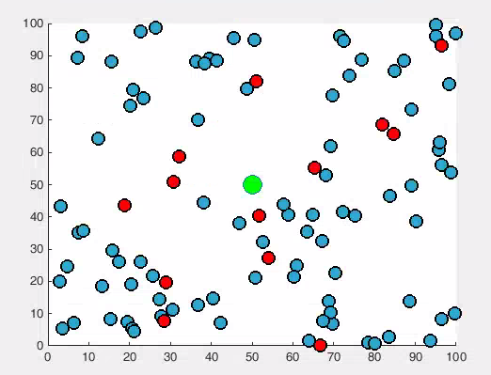

Fig 2: Distribution Of Cluster Heads Over The Network

CHAPTER 5
SYSTEM TESTING
System Testing is a type of software testing that is performed on a complete integrated system to evaluate the compliance of the system with the corresponding requirements. System testing detects defects within both the integrated units and the whole system. The result of system testing is the observed behavior of a component or a system when it is tested.System Testing is basically performed by a testing team that is independent of the development team that helps to test the quality of the system impartial. The purpose of testing is to discover errors. Testing is the process of trying to discover every conceivable fault or weakness in a work product. It provides a way to check the functionality of components, subassemblies, assemblies and/or a finished product. It is the process of exercising software with the intent of ensuring that the Software system meets its requirements and user expectations and does not fail in an unacceptable manner. There are various types of test. Each test type addresses a specific testing requirement.
OBJECTIVES OF TESTING
- Testing is the process of executing a program with the intent of finding an error.
- A successful test is one that uncovers a discovered the error.
5.1 TYPES OF TESTING
There are six testing phases
- Unit testing
- Integration testing
- Validation testing
- Acceptance testing
- Output testing
- System Implementation

UNIT TESTING
Unit testing involves the design of test cases that validate that the internal program logic is functioning properly, and that program input produces valid outputs. All decision branches and internal code flow should be validated. It is the testing of individual software units of the application. It is done after the completion of an individual unit before integration. The test set on which the models are evaluated contain the true classes and the evaluation tries to identify how many of the true classes were predicted by the model classifier. In The ML settings, special attention needs to be directed to the evaluation measures that are used. For data sets that are highly imbalanced (one class is overrepresented in comparison with another), standard evaluation measures like accuracy are not suitable. Because our data sets are imbalanced, we chose to report in addition to accuracy, the macro averaged F-measure. We decided to report macro and not micro averaged F-measure because the macro measure is not influenced by the majority class, as the micro measure is. The macro measure Better focuses on the performance the classifier has on the minority classes. The formulas for the evaluation measures are: Accuracy ¼ the total number of correctly classified instances; Recall ¼ the ratio of correctly classified positive instances to the total number of positives. This evaluation measure is known to the medical research community as sensitivity. Precision ¼ the ratio of correctly classified positive instances to the total number of classified as positive.
INTEGRATION TESTING
Software integration testing is the incremental integration testing of two or more integrated software components on a single platform to produce failures caused by interface defects. The task of the integration test is to check that components or software applications, e.g. components in a software system or one step up software applications at the company level interact without error. The following steps are applied in order to identify the final set of features to be used for classification: removing features that contain only punctuation, removing stop words (using the same list of words as for our BOW representation), and considering valid features only the lemma-based forms. We chose to use lemmas because there are a lot of inflected forms (e.g., plural forms) for the same word and the lemmatized form (the base form of a word) will give us the same base form for all of them.

VALIDATION TESTING
The procedure of validation testing is to keep the system safe from errors. The basic purpose is to conform that the system satisfies the necessary conditions. This testing is planned when the incorrect data is given; the user receives the error message. A test plan output lines the classes of test to be conducted and test a procedure device specific test case that will be used to demonstrate conformity with the requirements.
ACCEPTANCE TESTING
User Acceptance Testing is a critical phase of any project and requires significant participation by the end user. It also ensures that the system meets the functional requirements. The result will be verified by IBS, Kernel Buffer, and Memory Manager.
OUTPUT TESTING:
After performing the validation testing the next step is the output testing of the proposed system. Since no system could be useful if it does not produce the required output format. Asking the users about format required by them test the output generated or displayed by the system under consideration. Here the output form is considered on screen and in printed format.

CHAPTER 6
CONCLUSION AND FUTURE ENHANCEMENT
6.1 CONCLUSION
In this project, different clustering schemes are classified and discussed with special emphasis on their cluster head selection strategies. They are compared with respect to their requirement of clustering during each round for selecting the cluster heads, cluster formation required after each rotation of role of cluster head, distribution of cluster heads over the network, creation of balanced clusters, parameters used and the assistance considered to highlight the effect of cluster head selection strategy on the performance Particle Swarm Optimization (PSO) of these schemes. This survey also answers all the questions raised at starting stage about the clustering and cluster head selection sections. The use of these parameters for this comparison is justified by reasoning the effects of cluster head selection and its role rotation on the energy efficiency of the network. For multi-hop data forwarding, from cluster head to base station, distance between the forwarding clusterhead and intermediate cluster head shall be maintained approximately same, during different data gathering rounds, to ensure equal amount of energy consumption due to their data forwarding to or towards the base station. Finally it is concluded from the survey that, still it is needed to find more scalable, energy efficient and stable clustering scheme, for data gathering in wireless sensor networks
  - FUTURE ENHANCEMENT
For multi-hop data forwarding, from cluster head to base station, distance between the forwarding cluster head and intermediate cluster head shall be maintained approximately same, during different data gathering rounds, to ensure equal amount of energy consumption due to their data forwarding to or towards the base station. According to defined parameters in we create three scenarios, but in base parameters they were the same as above. In every scenario we change the traffic load and evaluate the performance.Finally it is concluded from the survey that, still it is needed to find more scalable, energy efficient and stable clustering scheme, for data gathering in wireless sensor networks.By enhancing the AI capability (bayestimator) an additional enhancement in MANET lifetime and resource consumption can be accomplished.
APPENDIX 1 SAMPLE CODING
clc;
numNodes = 100; % number of nodes
p = 0.1;
netArch = newNetwork(100, 100, 50, 50);
nodeArch = newNodes(netArch, numNodes);
figure(1), hold on
plot(nodeArch.nodesLoc(:, 1), nodeArch.nodesLoc(:, 2),'mo',...
'LineWidth',1.5,...
'MarkerEdgeColor','k',...
'MarkerFaceColor',[.17 0.66 .83],...
'MarkerSize',10)
plot(netArch.Sink.x, netArch.Sink.y,'o', ...
'MarkerSize',15, 'MarkerFaceColor', 'g');
[nodePos, best,Eng]=PSO_ECHS(nodeArch);
S=[nodeArch.nodesLoc(:, 1) nodeArch.nodesLoc(:, 2)];
BSx=50;
BSy=50;
no_node=length(S);
for i=1:no_node
sx=S(i,1);
sy=S(i,2);

for j=1:length(nodePos)
chx=S(nodePos(j),1);
chy=S(nodePos(j),2);
if(sx==chx && sy==chy)
break
end
Er=Eng(j);
X1 = [sx,sy;chx,chy];
dSCH = pdist(X1,'euclidean');
X2 = [chx,chy;BSx,BSy];
dCHBS = pdist(X2,'euclidean');
deg=nodeDeg(chx,chy,S);
we(j)=1*(Er/(dSCH*dCHBS*deg));
if isinf(we(j))
we(j)=0;
end
end
[B,I] = sort(we,'descend');
chx=S(nodePos(I(1)),1);
chy=S(nodePos(I(1)),2);
fprintf('Node = %d : (%f,%f) is joined with CH-%d : (%f,%f)\n',i,sx,sy,(I(1)),chx,chy);
end

for i=1:length(nodePos)
plot(nodeArch.nodesLoc(nodePos(i), 1), nodeArch.nodesLoc(nodePos(i), 2),'mo',...
'LineWidth',1.5,...
'MarkerEdgeColor','k',...
'MarkerFaceColor','r',...
'MarkerSize',10)
end
figure(2)
plot(best, 'LineWidth',2);
xlabel('Iteration');
ylabel('Best Fitness');
figure(3)
plot(Eng, 'LineWidth',2);
xlabel('CH');
ylabel('Energy');
function [nodePos,best,bestEng]= PSO_ECHS(nodeArch)
Np=15;
C1= 2.0;
C2= 2.0;
alpha= 0.3;
V1 = 0.5 ;
V2 = 0.7;
WC= 0.7;
D= 15;
Vmax= 200;
iter= 100;
S=[nodeArch.nodesLoc(:, 1) nodeArch.nodesLoc(:, 2)];
no_node=length(S);
Eng=nodeArch.node(:).energy;
empty_particle.Position=[];
empty_particle.Energy=[];
empty_particle.PosValue=[];
empty_particle.Fit=[];
empty_particle.Out=[];
empty_particle.Velocity=[];
empty_particle.Best.Position=[];
empty_particle.Best.PosValue=[];
empty_particle.Best.Energy=[];
empty_particle.Best.Ind=[];
empty_particle.Best.Out=[];
particle=repmat(empty_particle,Np,1);
BestSol.Cost=Inf;
Gbest=Inf;
GbestInd=-1;
BestCost=zeros(iter,1);
for i=1:Np
particle(i).Position=randperm(no_node,D);%unifrnd(0,Vmax,D);
positioni=particle(i).Position;
% positioni
particle(i).PosValue=zeros(D,2);
for k=1:length(positioni)
pos=positioni(1,k);
particle(i).Energy(k)=nodeArch.node(pos).energy;
cirx1=S(pos,1);
ciry1=S(pos,2);
particle(i).PosValue(k,1)=cirx1;
particle(i).PosValue(k,2)=ciry1;
end
energyi=particle(i).Energy;
particle(i).Velocity=zeros(D,2);
f1=computeF1(positioni,S,nodeArch);
f2=computeF2(positioni,S,nodeArch,energyi);

for m1=1:length(energyi)
particle(i).Energy(m1)=particle(i).Energy(m1)-(50*0.0001);
end
particle(i).Fit=alpha*f1+(1-alpha)*f2;
particle(i).Best.Position=particle(i).Position;
particle(i).Best.PosValue=particle(i).PosValue;
particle(i).Best.Energy=particle(i).Energy;
particle(i).Best.Cost=particle(i).Fit;
particle(i).Best.Ind=i;
fprintf('%d = %f : %f = %f\n',i,f1,f2,particle(i).Fit);
if particle(i).Best.Cost<BestSol.Cost %particle(i).Fit < Gbest
Gbest=particle(i).Fit;
GbestInd=i;
BestSol=particle(i).Best;
end
end
BestSol

for t=1:5%iter
for i=1:2%Np
for d1=1:D
particle(i).Velocity(d1,1)= WC*particle(i).Velocity(d1,1)+C1*V1*(particle(i).Best.PosValue(d1,1)-particle(i).PosValue(d1,1))+C2*V2*(BestSol.PosValue(d1,1)-particle(i).PosValue(d1,1));
particle(i).Velocity(d1,2)= WC*particle(i).Velocity(d1,2)+C1*V1*(particle(i).Best.PosValue(d1,2)-particle(i).PosValue(d1,2))+C2*V2*(BestSol.PosValue(d1,2)-particle(i).PosValue(d1,2));
end
for d1=1:D
particle(i).PosValue(d1,1)=particle(i).PosValue(d1,1)+particle(i).Velocity(d1,1);
particle(i).PosValue(d1,2)=particle(i).PosValue(d1,2)+particle(i).Velocity(d1,2);
if (particle(i).PosValue(d1,1)>100)
particle(i).PosValue(d1,1)=100;
elseif(particle(i).PosValue(d1,1)<0)
particle(i).PosValue(d1,1)=0;
end
if (particle(i).PosValue(d1,2)>100)
particle(i).PosValue(d1,2)=100;
elseif(particle(i).PosValue(d1,2)<0)
particle(i).PosValue(d1,2)=0;
end
% Assign new Position
pos= newNodePosition(S, particle(i).PosValue(d1,1), particle(i).PosValue(d1,2));
particle(i).Position(d1)=pos;
end
%particle(i).Position
positioni=particle(i).Position;
energyi=particle(i).Energy;
f1=computeF1(positioni,S,nodeArch);
for m1=1:length(energyi)
if rand>0.5
particle(i).Energy(m1)=particle(i).Energy(m1)-(50*0.0001);
else
particle(i).Energy(m1)=particle(i).Energy(m1)-(40*0.0001);
end
end
particle(i).Fit=alpha*f1+(1-alpha)*f2;

if particle(i).Fit<particle(i).Best.Cost
particle(i).Best.Position=particle(i).Position;
particle(i).Best.PosValue=particle(i).PosValue;
particle(i).Best.Energy=particle(i).Energy;
particle(i).Best.Cost=particle(i).Fit;
end
if particle(i).Best.Cost < BestSol.Cost
BestSol=particle(i).Best;
end
end
for d1=1:D
pos= newNodePosition(S, particle(i).PosValue(d1,1), particle(i).PosValue(d1,2));
particle(i).Position(d1)=pos;
end
BestCost(t)=BestSol.Cost;
end
BestSol

nodePos=BestSol.Position;
best=BestCost;
bestEng=BestSol.Energy;
end

APPENDIX 2 SCREENSHOTS
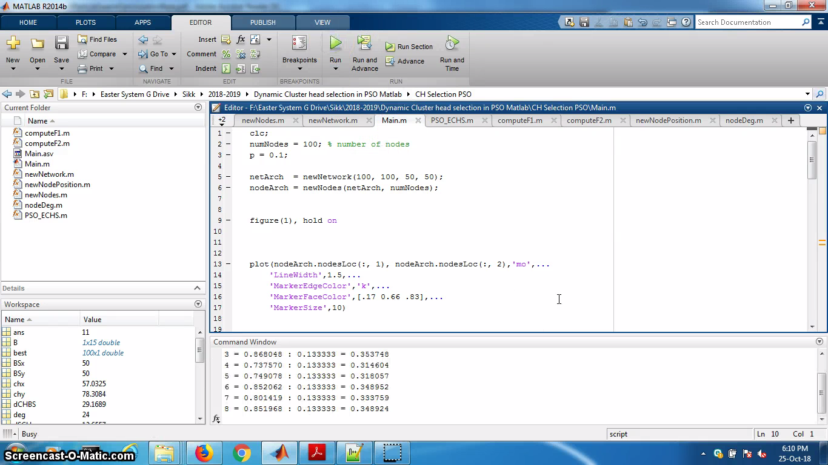
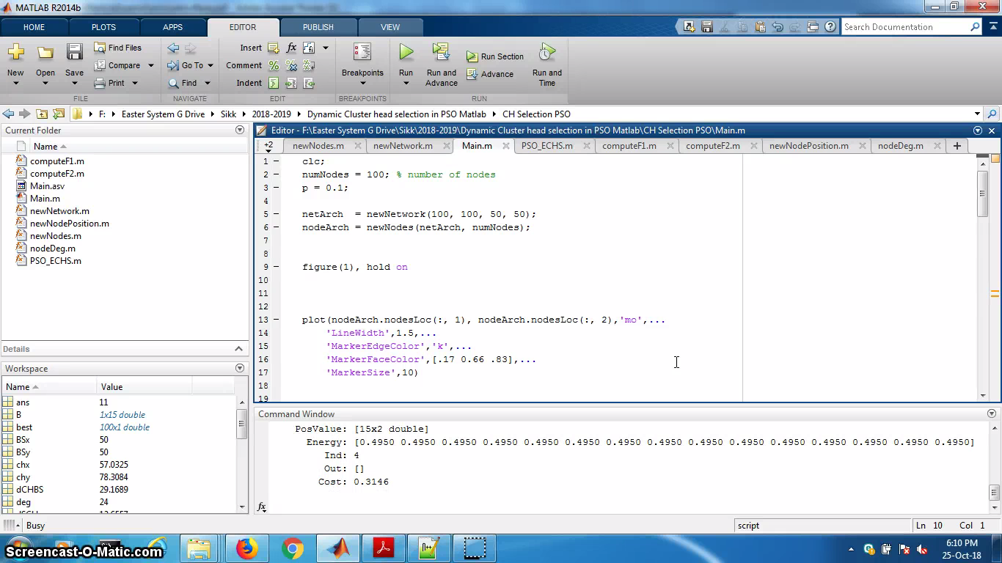

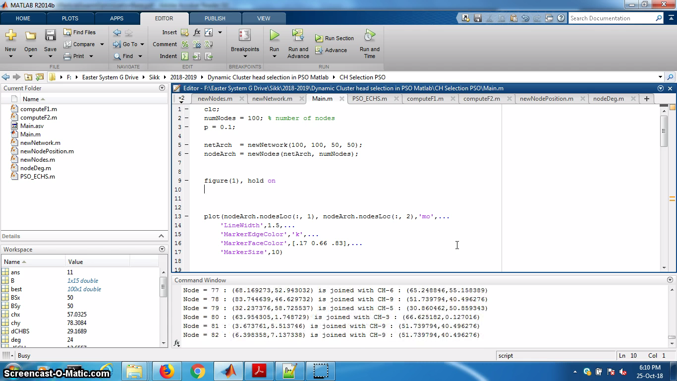
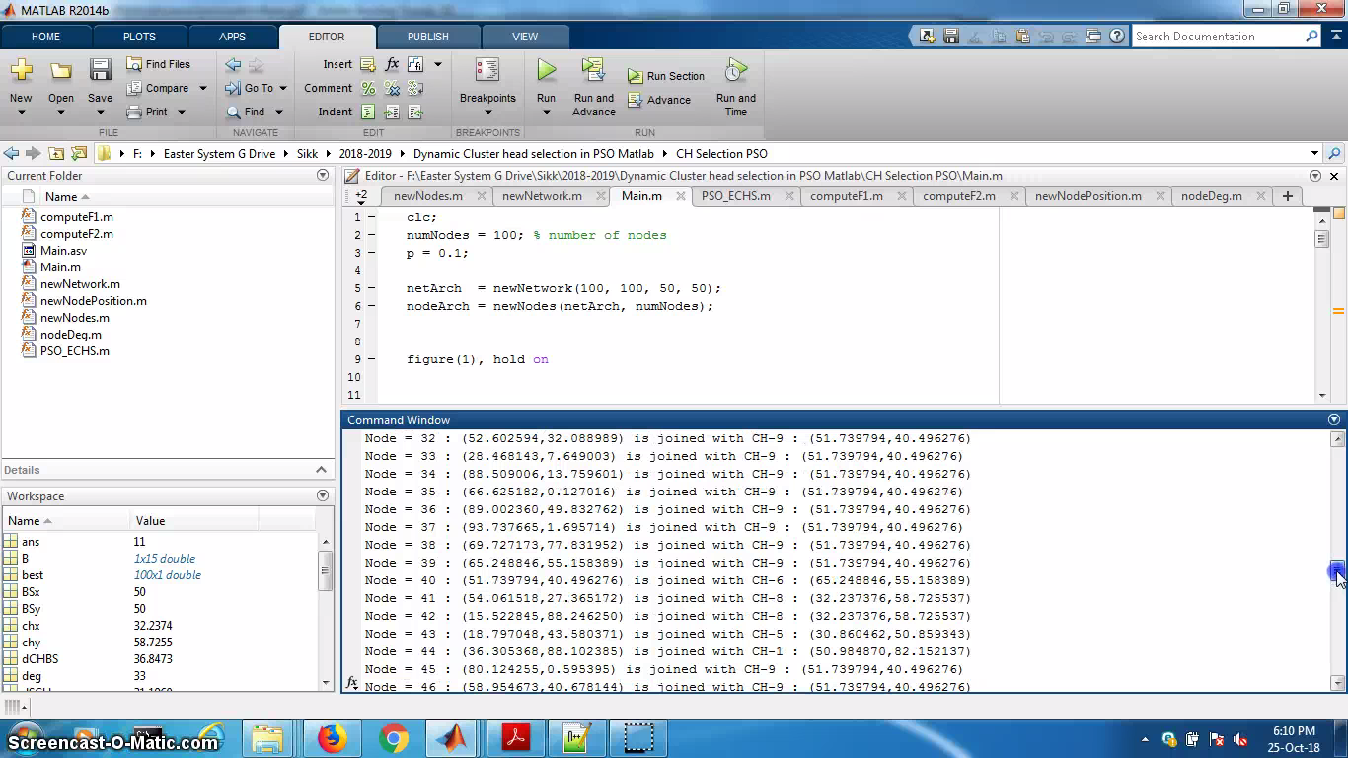

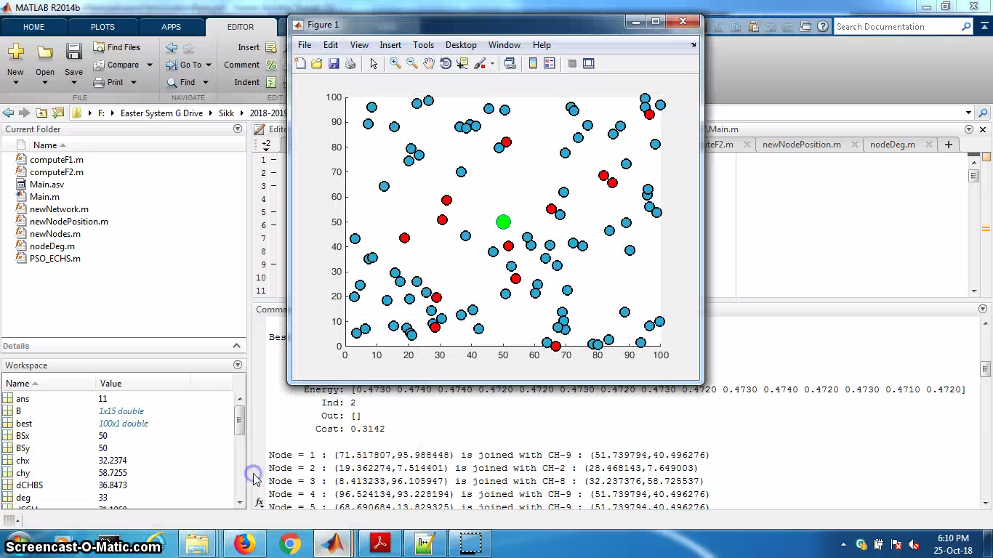
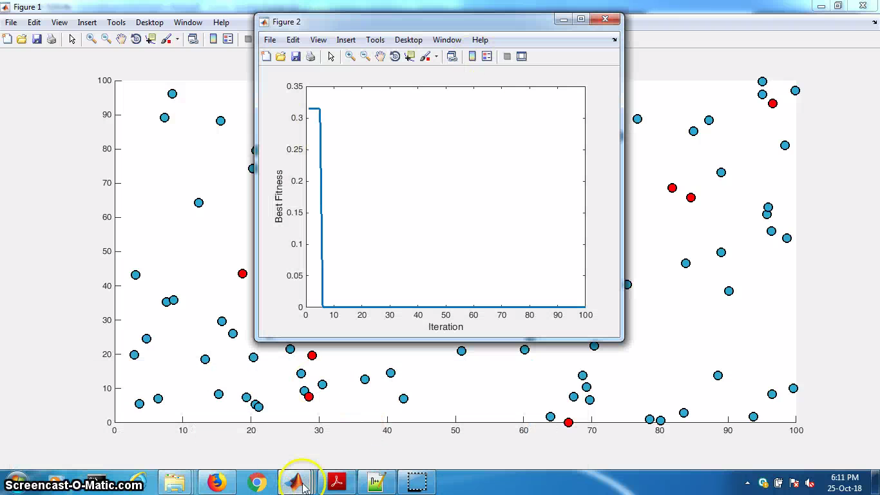
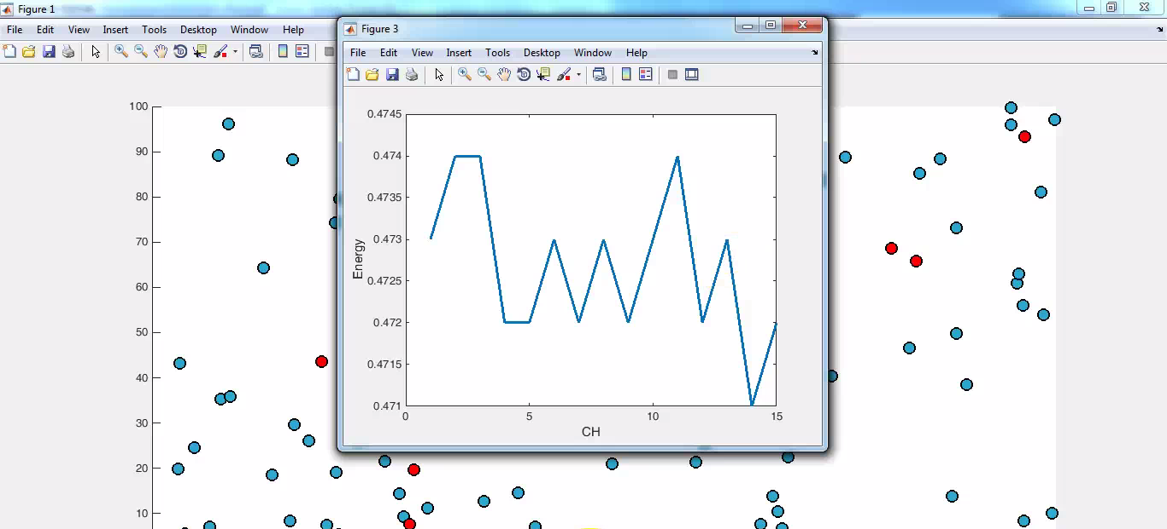

REFERENCES
- Jamal N. Al-Karaki, Ahmed E Kamal, “ Routing Techniques in Wireless Sensor Network: A Survey”, IEEE Wireless Communication December 2004.
- I.F. Akyildiz, W. Su, Y. Sankarasubramaniam, and E. Cayirci, “A Survey on Sensor Network”, IEEE Communication Magazine, vol. 40, no.8, pp. 102-116, August 2002.
- Bhardwaj, M. and A. Chandrakasan, Bounding the lifetime of sensor networks via optimal role, assignments, Proc. of the INFOCOM’02, pp.1587-1596, 2002.
- Chang, J. H. and L. Tassiulas, Routing for maximum system lifetime in wireless Ad Hoc networks, Proc. of the ACCCC’99, 1999.
- Chang, J. H. and L. Tassiulas, Maximum lifetime routing in wireless sensor networks, IEEE/ACM Trans. on Networking, vol.12, no.4, pp.609-619, 2004.
- Rodoplu, V. and T. H. Meng, Minimum energy eobile wireless networks, IEEE JSAC, vol.17, no.8, pp.1333-1344, 1999.
- Zussman, G. and A. Segall, Energy efficient routing in Ad Hoc disaster recovery networks, Proc. Of the INFOCOM’03, pp.682-691, 2003.
- Estrin, D.; Govindan, R.; Heidemann, J. and Kumar, S., “Next Century Challenges: Scalable Coordination in Sensor Networks ,” Proceedings of 5th annual IEEE/ACM international conference on Mobile Computing and Networking, pp. 263-270, 1999.
- Q. Cao, T. Abdelzaher, T. He, and R. Kravets, “Cluster-Based Forwarding for Reliable End-to-End Delivery in Wireless Sensor Networks”, IEEE Infocom’07, May 2007.
- Wood, A. D., and Stankovic, J. A., Security of Distributed, Ubiquitous, and Embedded Computing Platforms, to appear in Wiley Handbook of Science and Technology for Homeland Security, Voeller, J. G. (Ed.), John Wiley & Sons, Hoboken, NJ, 2008.

